**Standard Operating Procedure**

**Arc Welding**



**ODISHA MINING CORPORATION LTD.**

**KODINGAMALI BAUXITE MINE**

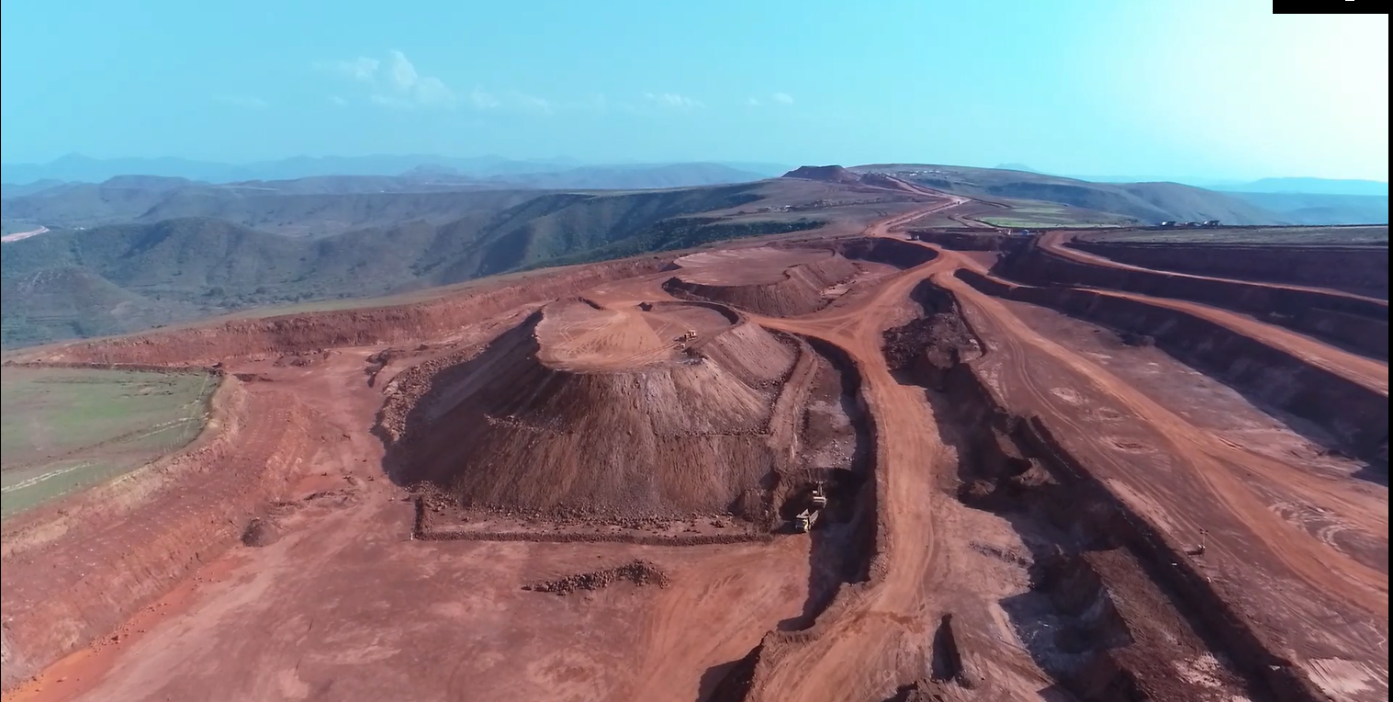

**Authorized By**

**PURPOSE:** The SOP shall be followed where welding activity will be carried out& to prevent work men from the hazards arises out from the arc welding.

**SCOPE:** The Procedure is applicable to all areas of Workshop where Arc welding activities will be carried on.

**PRE-OPERATIONAL SAFETY CHECKS:**

1. Ensure the welder is used in a suitable safe work area.

2. Ensure all cables are correctly fastened, free of cracks and splits and unwound before work.

3. Keep the area clean & free of grease, oils & flammables.

4. Ensure other workers are protected from any UV flash.

5. Ensure the area is well ventilated (with fume extraction as required).

**OPERATIONAL SAFETY CHECKS:**

1. Ensure the welder is correctly set up for current, voltage and good earth.

2. Ensure that other workers in this locality are protected from any UV & IR radiation flash. Always close the UV curtain to the welding bay or erect a UV screen.

3. Ensure the welding return cable (earth) makes firm contact to provide a good electrical contact.

4. Ensure your work piece has been prepared to be free of any paint, oxides or other surface finishes ensuring a good electrical contact.

5. Take particular care to avoid accidental UV welding flash to the skin or eyes.

6. Never leave the welder running unattended.

7. Regularly inspect the welding tip and shield for damage.

8. When welding is finished or interrupted, turn off the welder and secure the hand piece safely.

9. Ensure the work area can isolate hot areas from workers to avoid hot surfaces until job is cool.

**HOUSEKEEPING:**

1. Ensure the welder is switched off (and fume extraction if used).

2. Check for any damage to welder and cables at the end of job. Wind up cables.

3. Hang up the welding hand piece and cables securely.

4. Check contact points for damage or corrosion.

5. Leave the work area and welding bench in a safe, clean, and tidy condition.

**POTENTIAL HAZARDS:**

1. Welding flash eye injury - correct use of PPE, maintain or replace

2. Burns - Correct use of protective clothing / PPE and hot work mats

3. Eye injury, hot slag - Protective glasses or face shield when removing weld slag

4. Fire and explosion - Clean work area and correct use of hot mats

**PROCEDURE:**

1. Ensure Proper Housekeeping check before staring of work.

2. Ensure the compliance of pre operational safety check.

3. While workings ensure that operational safety checks are complied.

4. In case of any safety compromises ensure to act as per the emergency response plan.

5. Ensure proper housekeeping post operation.